Assignment/Project Cover Sheet

Grade:

Course Code/Title : ME323 / Mechanics of Materials

Section Number : U1

Instructor Name : Dr. Javad Farookhi

Semester/Year : Fall 2019

Student Name(s) | Student Number

Contents
Abstract 3
Problem definition: 3
Sketch of the arm: 4
Solid work: 4
Maximum forces: 4
Used material: 5
Material properties: 5
Work plan: 5
Calculations: 6
Solid work simulation 12
Conclusion: 15
References 16

Figure 1: bicep\triceps machine 3
Figure 2: machine dimensions 3
Figure 3: 3D arm model 4
Figure 4: solid work simulation (stress) 13
Figure 5: solid work simulation(deflection) 13
Figure 6: solid work simulation (F.O.S) 14

Table 1: Mechanical properties 5
Table 2: physical properties 5

Abstract
Our course project focuses on a machine which is called “solid bicep/tricep machine”. The main aim of this project is to connect the real life applications to the concepts of mechanics of materials, throughout this project a full stress and deflection analysis to the metallic arm will be presented to meet the project requirements, in the first deliverable of the project a brief review will be presented in terms of application, function, materials, manufacturing process and mechanical properties, and solid work model. The second deliverable will include full calculations for the different types of stresses, deflection and factor of safety, in addition to a solid work model will be subjected to the same conditions and the simulation results will be compared to the manual calculations and the results will be discussed. Throughout deliverable 2, the different types of stresses resulted from the applied force will be calculated in addition to selecting the maximum stresses in order to calculate the factor of safety. Finally, the different types of deflections will be calculated specially the deflection at point A (deflection due to transvers loading). The simulation will be done through solid works and the final results will be compared with the manual calculation.

Introduction:
There are many types of body building machines which provides you strength muscles and helps you to remove fat. According to our project, we need to study about a solid tricep/bicep machine. The triceps/bicep machine mostly trains your rear end upper arm muscles. That means you can accomplish or gain with effort stronger triceps faster than ever. The upper arm is made up of two most important muscle groups-the biceps and the triceps, and it is equally important to train both. Triceps Part provides a very smooth change from bicep exercise to triceps exercise with dual grip handles. It able to be changed or moved the way of the seat. upper arm pad is designed to match up the elbow with the rotational axis of the lifting arm. The machine's handle spins around to improve user comfort. The triceps/ biceps machine can be used in the gym and also, we can use it at home while having the device. The biceps and triceps muscles work together to permit you to twist and fix your elbow. Once you need to twist your elbow, your biceps muscle contracts and, at the same time, the triceps muscle unwinds. To fix the elbow, the triceps contract and the biceps relax. It contains a chair that’s made from iron and it’s covered by sponge and the sponge is also covered by a strong leather. Also, it contains a body that’s made from iron, but there are some factories that manufacture the body from aluminum, but the most common material that’s used to manufacture the machine body is iron. The handle of the arm is made from sponge so it’ll be more comfortable to use. There are many manufacturing materials for this machine such as, carbon steel, wood, titanium, copper and stainless steel.

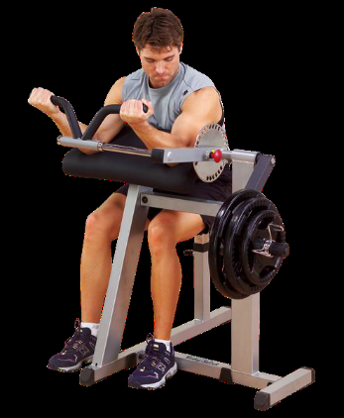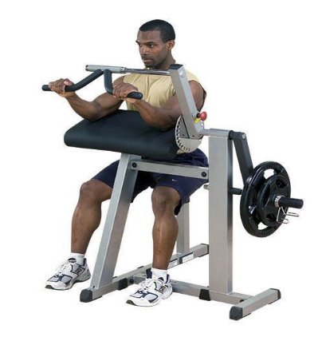
Figure 1: body-solid bicep/tricep machine

Problem definition:
Our project asked us to do a research about a body building machine which is called “bicep/triceps” machine. We’re going to do that by applying the knowledge that we’ve learned during this course. To meet the project requirements, we have to calculate the maximum stress, deflection and factor of safety to the machine’s arm. To get them we are asked to draw a skitch for the arm, also using solid work software to design a 3D model of the arm. Also, the maximum force that the person can apply at the handles. Also need to research about the best material used to manufacture the machine’s arm. And compare the simulation results that we will be taken from solid work with our manual calculations for the next deliverable.

Sketch of the arm:
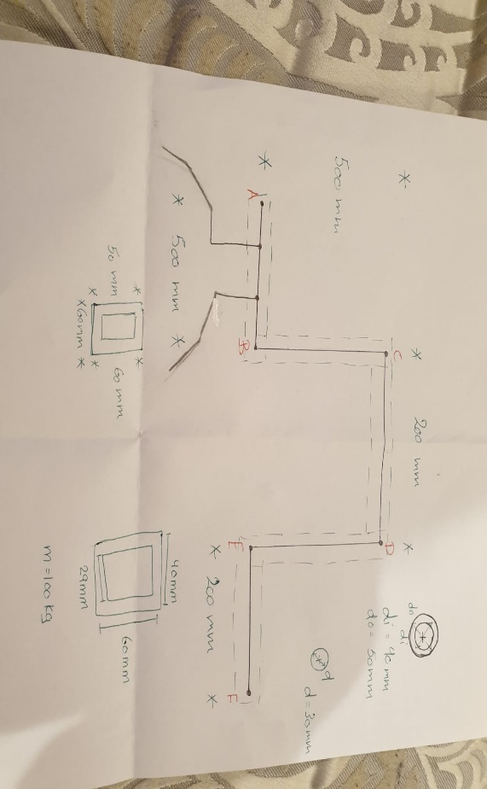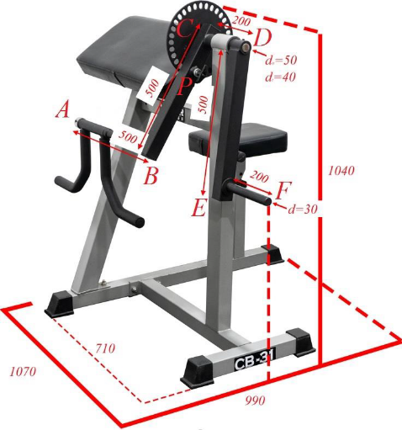
Figure 2: machine dimensions

By using the given dimensions in (figure 2), we drew a solid work model (figure3). Since (figure 2) had missing dimensions, we had to assume some dimensions in order to complete our 3D work model.

Solid work:
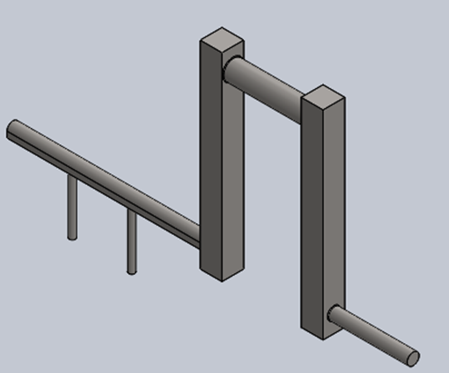
Figure 3: 3D arm model

Maximum forces:
To find the maximum stress and deflection forces, first we need to know the maximum mass of the person that would use the machine, which is given as a 100 Kg. Next, we multiply the mass with the gravity constant that equals 9.81m/s². Since we have only one shear stress, we’ll divide it by one then we’ll get the maximum force that’s used on this arm. We can illustrate all of that in the following equation: $\frac{100*9.81}{1}=981$
Therefore, the maximum force is 981 N

Used material:
The arm of the bicep/tricep machine is a round tube made of strong material and in some machines, the arms are covered with leather to protect our hands while using it. After researching, we found that carbon steel 1020 is the best material used to manufacture this machine because Carbon steel 1020 has low hardenability properties, has machinability, high strength, ductility and best weldability. It’s usually used in turned and polished or a cold drawn condition. Because it doesn’t have a lot of carbon, it can refuse and resist induction hardening. Also, it is the lack of mixture elements that it won’t reply to nitriding. Carbon steel 1020 has also qualities that specialize it, less expensive, and it’s safe. There are a lot of properties that led us into choosing this material (Azom,2019).

Material properties:
- Mechanical properties:
Table 1: Mechanical properties
Yield Strength ($σy$ ) | 350 Mpa
Shear modulus | 80 Gpa
Elastic modulus (E) | 205 Gpa
Tensile Strength ($σ_{T}$) | 420 Mpa

- Physical properties:
Table 2: physical properties
Mass Density (ρ) | 7870 kg/m³

Work plan:
For deliverable 2, we need to get the average normal stress due to axial loading, average shearing stress due to transverse loading, the maximum shearing stress due to the torsional load, the maximum stresses due to the bending behaviour. Then, select the maximum normal and shear stresses. Also, the most important thing we need to get the factor of safety of the machine. Finally, we need to get the deflection at A.

Calculations:
To do our hand calculations we are provided by some givens and dimensions from our sketch diagram, as we used those givens information as a reference to calculate the needed requirements. The given information is:
Yield Strength ($σy$ ): 350 MPa
Shear modulus (G): 80 GPa
Elastic modulus (E): 205 GPa
Tensile Strength ($σ_{T}$): 420 MPa
Pin diameter: 12 mm
Maximum force: 981 N
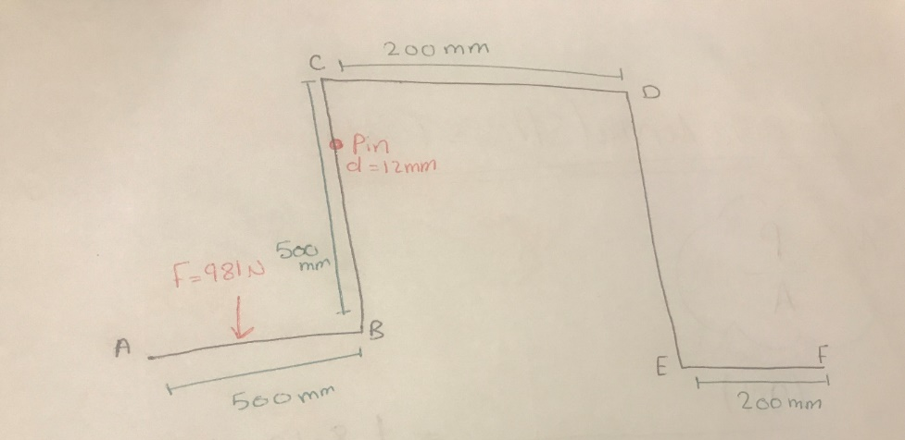

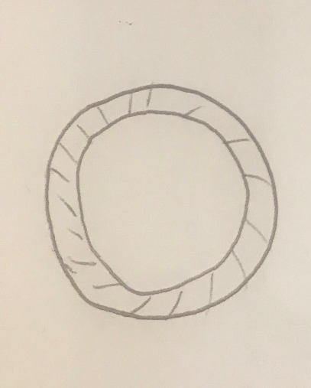
Part AB and CD are hollow and the outer diameter = 50mm, the inner diameter = 40mm, and the thickness = 5mm
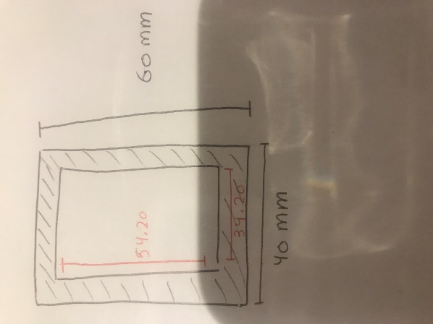
For part BC and DE which are hollow also the thickness = 2.9mm
And the dimensions for the inner rectangle the length is 54.20 mm and the width is 34.20 mm. for the outer rectangular the length is 60 mm and the width is 40 mm as shown in the upper sketch.
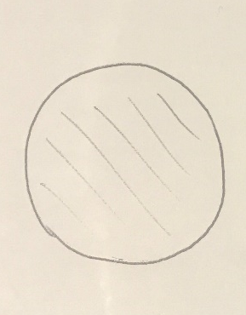
For part EF which is a solid, the diameter of the part = 30 mm
- Average normal stress:
$$σ=\frac{p}{A}$$

$σ \left(BC ,DE\right)=\frac{-981 }{\left(60*40\right)-(54.2*34.20)}=-1.8 MPa$ (compression)
$$σ \left( AB\right)=\frac{981}{\frac{π}{4}*({50}^{2}-{40}^{2})}=1.4 MPa$$
$$σ \left( EF\right)=\frac{981}{\frac{π}{4}*({30}^{2})}=1.4 MPa$$

- Average shearing stress:
$$τ=\frac{P}{n*A}$$
Since we have single shear stress so,
$$τ=\frac{981}{1*\frac{π}{4}*({12}^{2})}=8.7 MPa$$

- Bearing stress:
$$σb=\frac{P}{ntd}$$

$$σb\left(link BC\right)=\frac{981}{2*12*2.9}=14.09 MPa$$

- Maximum shearing stress due to torsional loading:
$$τ(hollow CD)=\frac{T*Co}{J}$$
To calculate it we need to calculate some missing information:
- T= $F*d$ = 981 $*\frac{500}{2}$ = 245.25 $*{10}^{3}$ N.mm
- Co = $\frac{do}{2}$ = $\frac{50}{2}$ = 25 mm
- Ci=$\frac{di}{2}$ = $\frac{40}{2}$ = 20 mm
- J= $\frac{π}{2}*\left({Co}^{4}-{Ci}^{4} \right)$= $\frac{π}{2}*\left({25}^{4}-{20}^{4} \right)$= 362.3 $*{10}^{3}$ ${mm}^{4}$

Now from our calculations we can get the maximum shearing stress due to torsional loading : $$τ\left(hollow CD\right)=\frac{245.25*{10}^{3}*25}{ 362.3 *{10}^{3}}=16.95 MPa$$

- Maximum normal stress due to bending behavior:
$$σm(CB)=\frac{M*C}{I}$$
To get it there are some missing information we need to calculate so we can use them in the formula and get the maximum normal stress
- M= P* the distance between the force to the center of the body = $$=981*\left(\frac{500}{2}-\frac{40}{2}\right)=264.87*{10}^{3} N.mm$$

- Cx= 40/2 = 20 mm

- Iy= $\left(\frac{60*{40}^{3}}{12}-\frac{54.2*{34.20}^{3}}{12}\right)=139.3*{10}^{3 } mm^{4}$

Now we can get the Maximum normal stress due to bending behavior:
$$σm\left(CB\right)=\frac{264.87*{10}^{3}*20}{139.3*{10}^{3 }}=38.02 MPa$$

$$σm(ED)=\frac{M*C}{I}$$
- M= P* the distance between the force to the center of the body =
$981*\left(\frac{200}{2}-\frac{40}{2}\right)=117.72*{10}^{3} N.mm$

- Cx= 40/2 = 20 mm
- Iy= $\left(\frac{60*{40}^{3}}{12}-\frac{54.2*{34.20}^{3}}{12}\right)=139.3*{10}^{3 } mm^{4}$
$$σm\left(ED\right)=\frac{117.72*{10}^{3}*20}{139.3*{10}^{3 }}=16.9 MPa$$

- Eccentric loading:
-Due to tension condition:
$σ=\frac{P}{A}+\frac{M*C}{I}$ = 1.8 + 38.02 = 39.82 MPa

- Due to compression loading:
$σ=\frac{P}{A}-\frac{M*C}{I}$ = 1.8 - 38.02 = -36.22 MPa

- Maximum normal and shear stress
- Maximum normal stresses due to bending: $σm=38.02 MPa$
- Maximum normal stresses due to eccentric loading: $σT=39.82 MPa$
- Maximum shear stress due to torsion: $τ=16.95 MPa$

- Factor of safety:
- due to normal stress condition:
F.O.S=$\frac{ultimate normal stress}{allowable normal stress}$
F.O. S=$\frac{350}{38.03}=9.2$ due to bending
F.O. S=$\frac{350}{39.82}=8.8$ due to eccentric loading

- due to shear stress condition:
$$τyield=0.6*350=210 MPa$$

F.O.S=$\frac{ultimate shear stress}{allowable shear stress}=\frac{210}{16.95}=12.4$
After calculating the factor of safety for both normal and shear stress, we will choose the factor of safety = 8.80 (failure condition)

- Deflection at point A:
First of all, we need to calculate moment around point B.
∑M=0
(-P*X) +M=0
M=P*X
The required equation is:
$$\frac{d^{2}y}{dx^{2}}=\frac{M\left(x\right)}{E*I}$$
$$\int{\frac{d^{2}y}{dx^{2}}=\frac{1}{E*I} \int{(P*X)}}$$

$$θ\left(x\right)=\frac{dy}{dx}=\frac{1}{E*I}\left(\frac{P*X^{2}}{2}+C1\right)$$
And this is the slope equation (equation 1)
$$\int{\frac{dy}{dx}}=\frac{1}{E*I}\int{(\frac{P*X^{2}}{2}+C1)}$$
$$Y\left(x\right)=\frac{1}{E*I}(\frac{P*X^{3}}{6}+C1*X+C2)$$
This is the deflection equation (equation 2)

For point A:
XA=0
YA=EXIST
$θA$= EXIST

For point B:
XB=L
YB=0
$θB$= 0 (Fixed support)

From equation 1, point B:
0 =$\frac{1}{E*I}(\frac{P*L^{2}}{2}+C1)$
$$C1=-\frac{P*L^{2}}{2}$$

From equation 2, point B:
$$0=\frac{1}{E*I}(-\frac{P*L^{3}}{6}+\frac{P*L^{2}}{2}*L+C2)$$

$$C2=\frac{P*L^{3}}{3}$$

$$θ\left(x\right)=\frac{1}{E*I}\left(\frac{P*X^{2}}{2}-\frac{P*L^{2}}{2}\right)$$

$$Y\left(x\right)=\frac{1}{E*I}(\frac{P*X^{3}}{6}-\frac{P*L^{2}}{2}*X+\frac{P*L^{3}}{3})$$

Deflection at point A (XA=0):
$$Y\left(A\right)=\frac{1}{E*I}(\frac{P*0^{3}}{6}+\frac{P*L^{2}}{2}*0+\frac{P*L^{3}}{3})$$

$$Y\left(A\right)=\frac{P*L^{3}}{3E*I}$$

$$Y\left(A\right)=\frac{981*({500)}^{3}}{3*200*{10}^{3}*\frac{π}{64}*\left({50}^{4}-{40}^{4}\right)}=1.13 mm$$
Point A moves upward
The slope at point A:
$$θ\left(A\right)=\frac{1}{E*I}\left(\frac{P*0}{2}-\frac{P*L^{2}}{2}\right)=-\frac{PL^{2}}{2*E*I}=\frac{981*{500}^{2}}{2*204.9*{10}^{3}*181.1*{10}^{3}}=-3.3*{10}^{-3} rad$$

- Axial deflection:
$$δ\left(BC,DE\right)=\frac{P*L}{E*A}=\frac{981*500}{205*{10}^{3}(\left(60*40\right)-\left(54.2*34.2\right))}=4.37*{10}^{-3} mm$$
K) Angle of twist:
$$∅=\frac{T*L}{G*J}=\frac{245.25*{10}^{3}*200}{80*{10}^{3}*362.3*{10}^{3}}=1.69*{10}^{-3} rad$$

Solid work simulation

By using solid work software, we create and draw the arm and we applied the maximum force on it. We run the simulation and these are the results that we got:

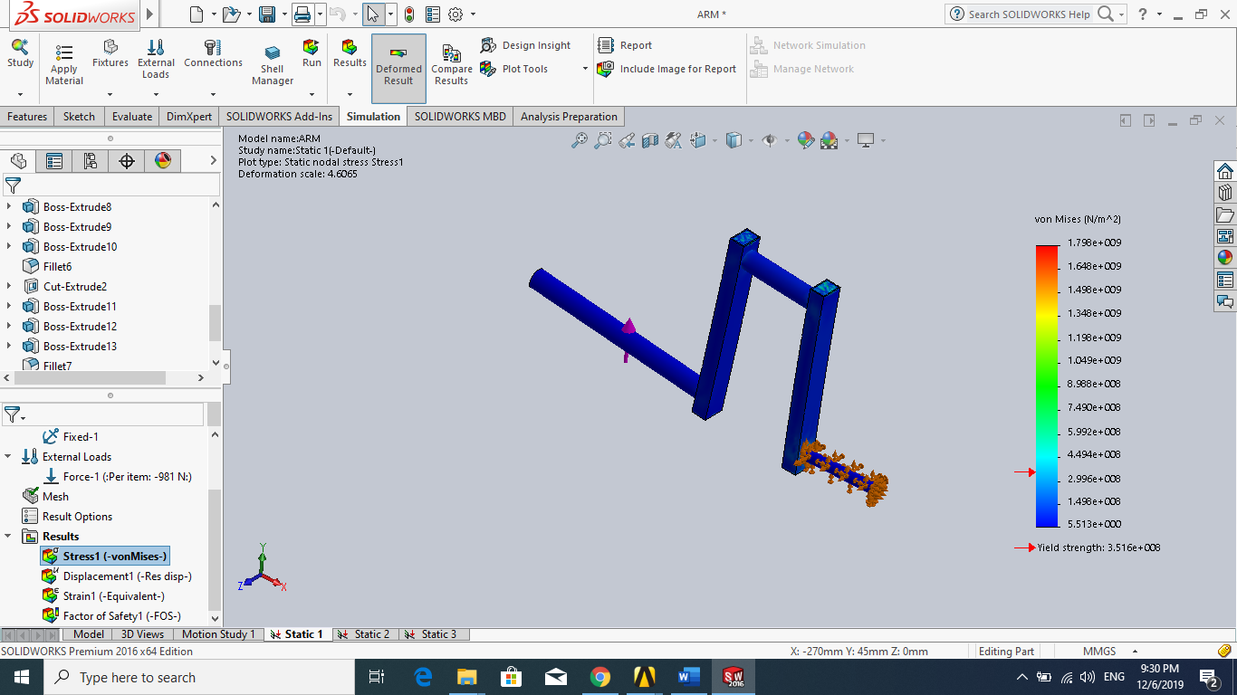
Figure 4: solid work simulation (stress)

From figure 4, the maximum stress equals to $1.798*{10}^{9}$
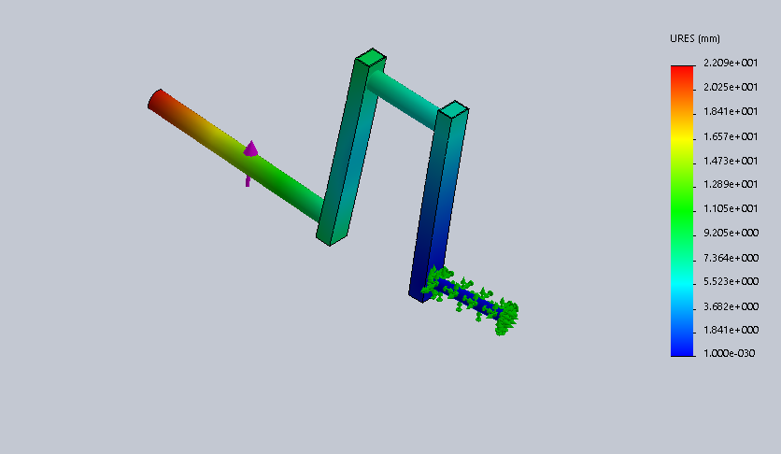

Figure 5: solid work simulation(deflection)
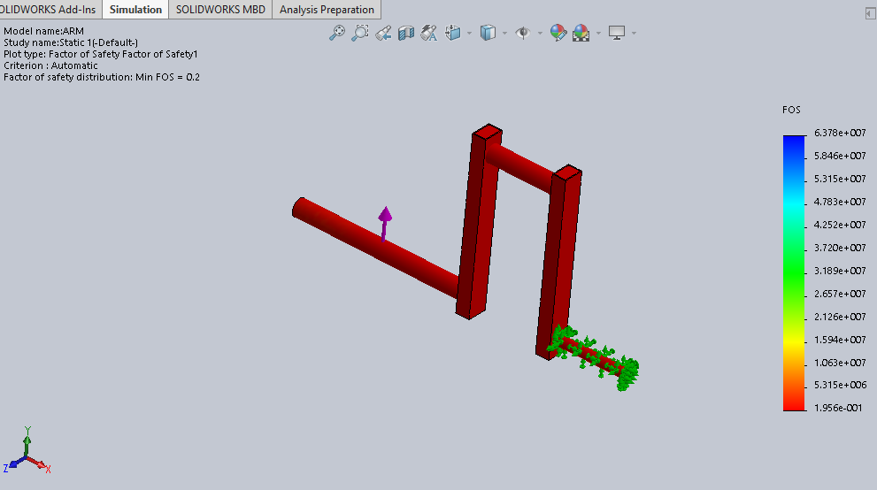
From figure (5) the deflection=$2.2*{10}^{1}$

Figure 6: solid work simulation (F.O.S)
From figure 6, the factor of safety almost equals to 0.2 which is not safe it should be more than 1 so we can have a safe machine

From our simulation that we got from the software, we figured that the machine is not safe enough and there is a different in results between hand calculation and the results that we got through solid work software. The reasons behind this huge different is because the program is calculating von mises (3D, stresses). The calculations are depending on plane stresses but the software depends on 3D stresses. And the software is more accurate than the hand calculations, the software takes the factor of overall object.

Conclusion:
In conclusion, we were able to know the problem of the bicep/tricep machine, and we were able to know better about this machine. Also, we were able to define the best material to manufacture the machine. By using a simple equation to show how we can get the maximum force, also by assuming some dimensions and the given ones we create a solid work model, then we talked about our working plan for the next deliverable, which is the final result we will get by calculating the total forces we’ve learned in the course.

References
https://www.azom.com/article.aspx?ArticleID=6114

